PM-03: Intermediate Programming with JavaScript
Activity 3.1: Debugging and Error Handling
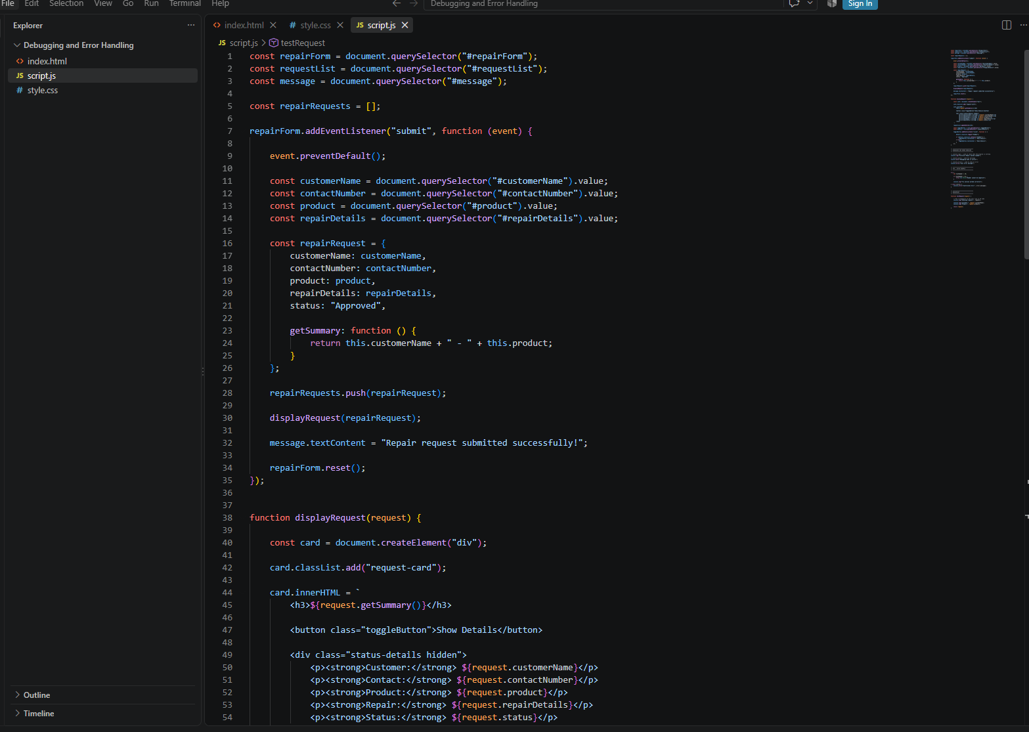
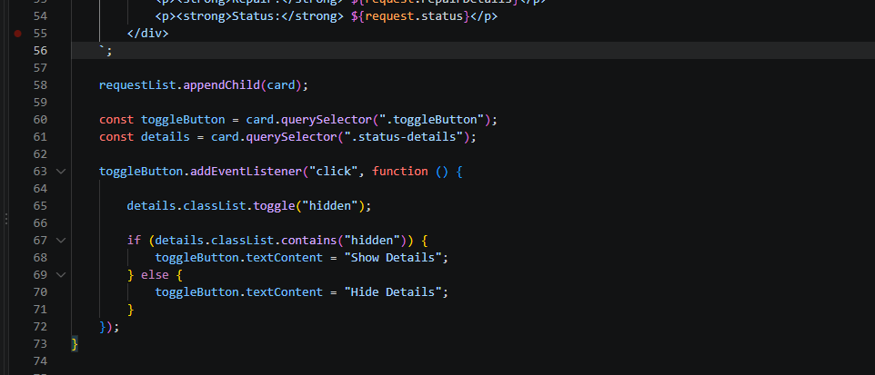

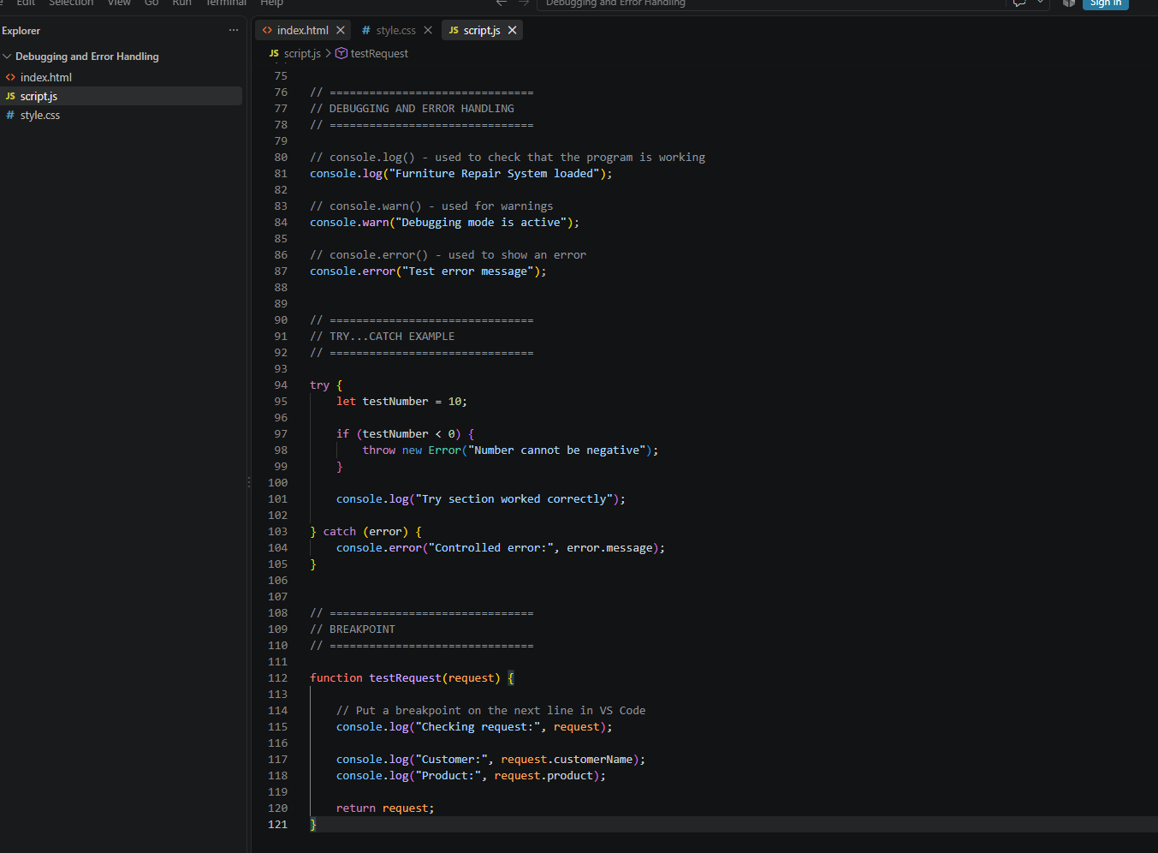
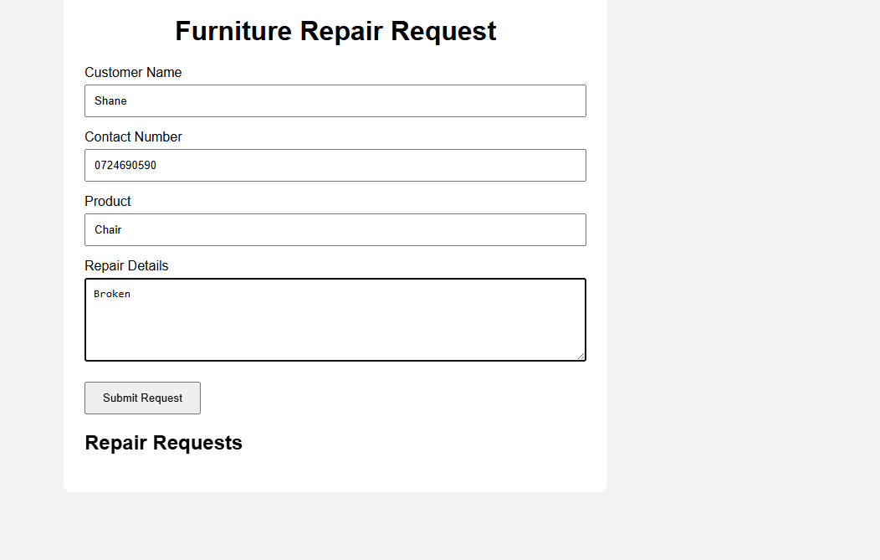

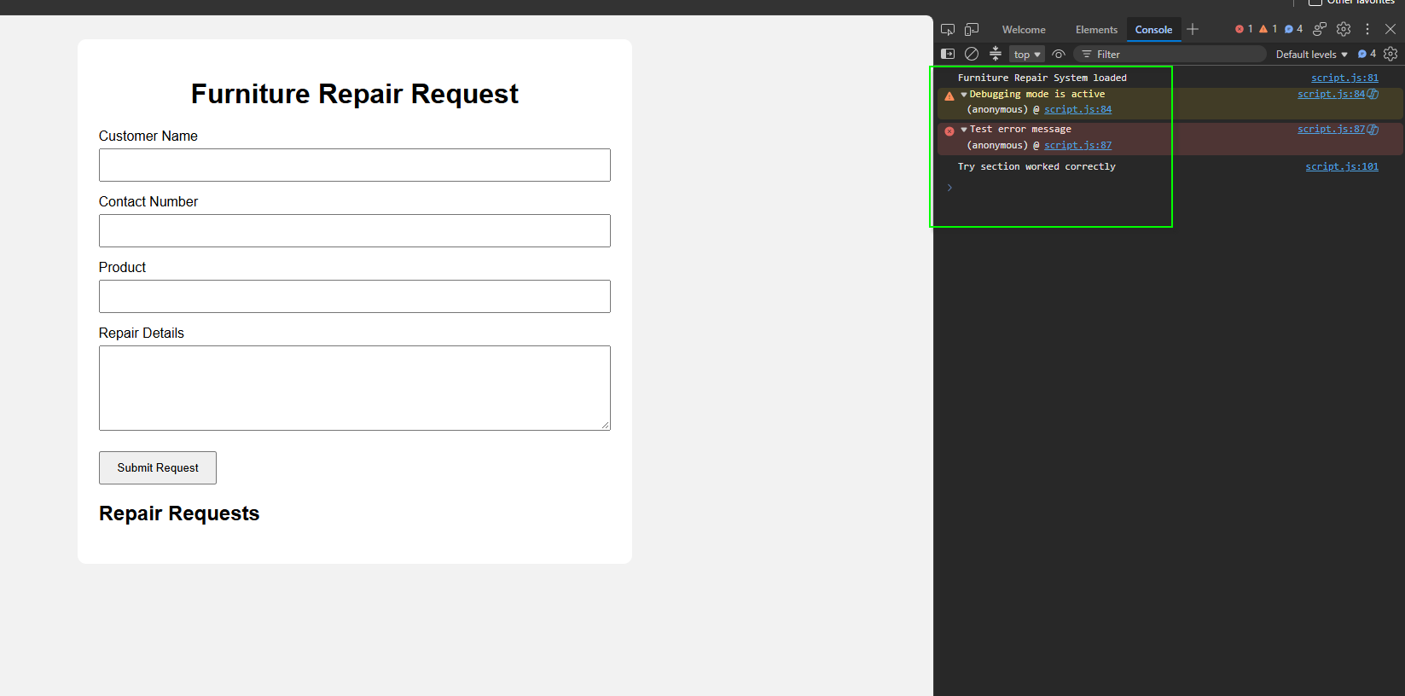

Correct at least three seeded errors
Seeded 1
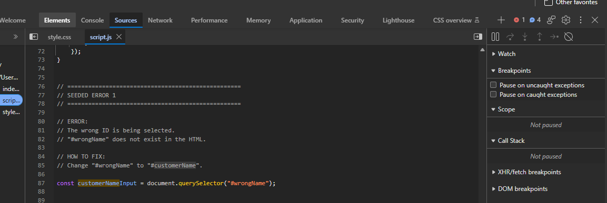
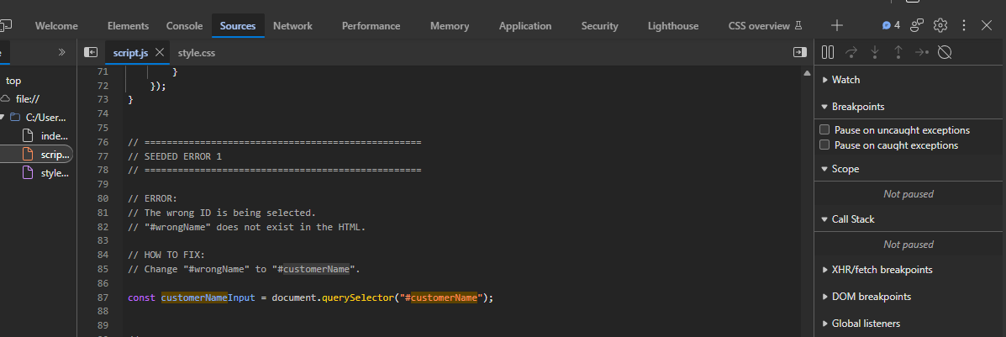

Seeded 2
Before:
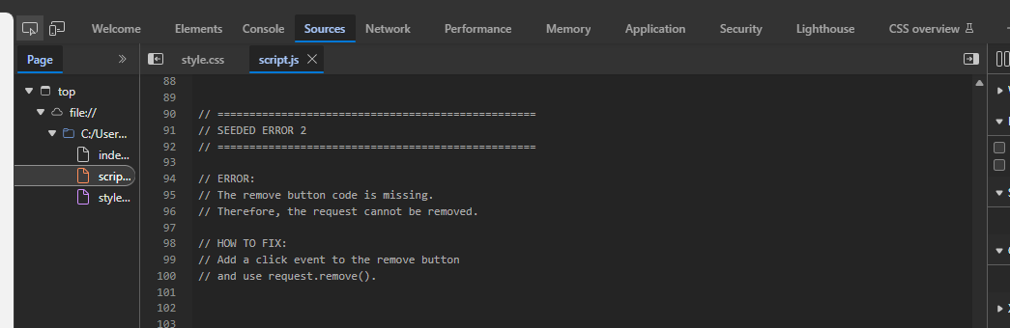

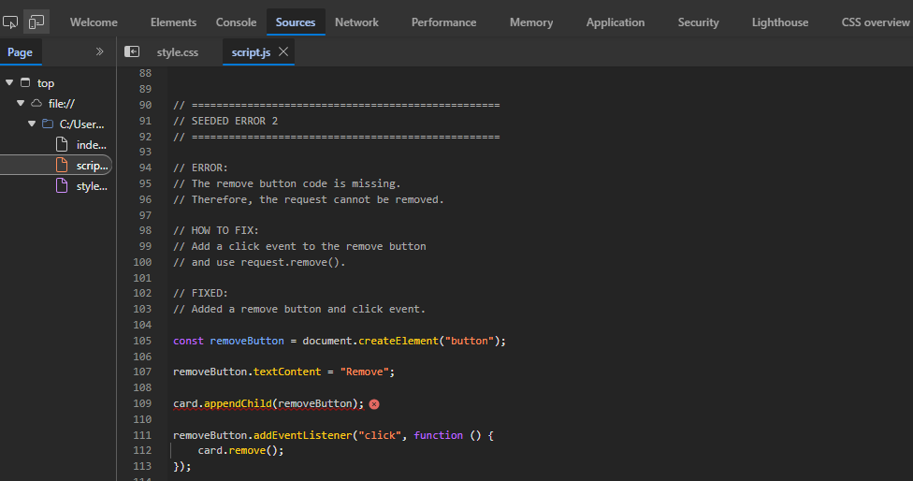
Seeded 3
Before:
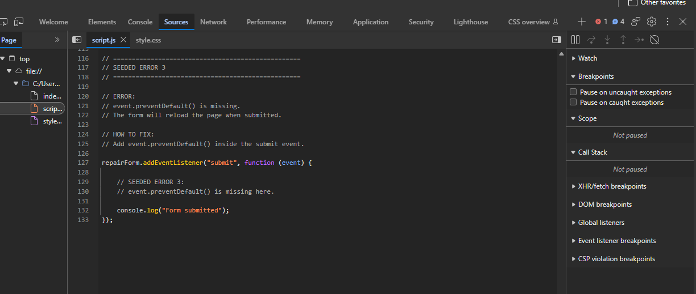

After:
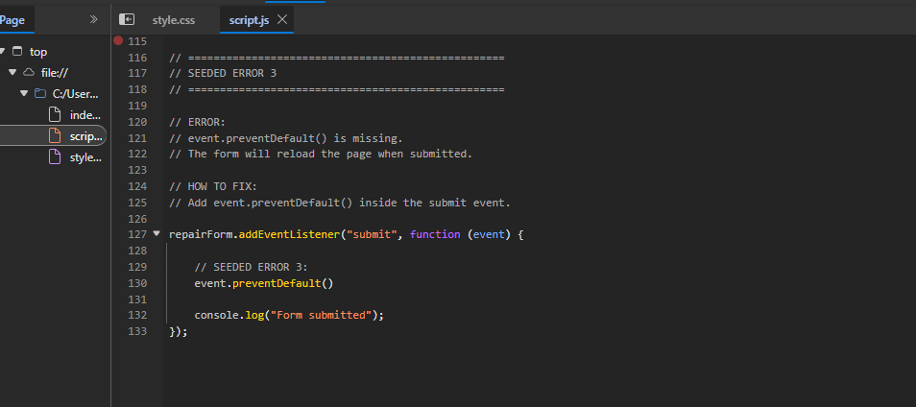

Use a breakpoint and step through code

`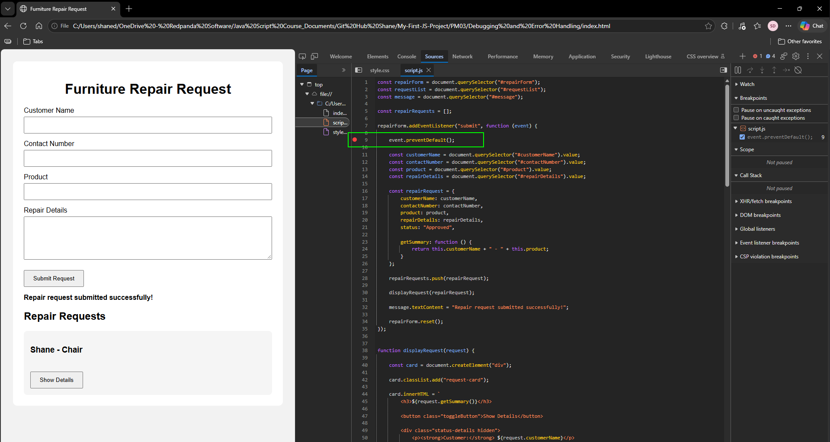
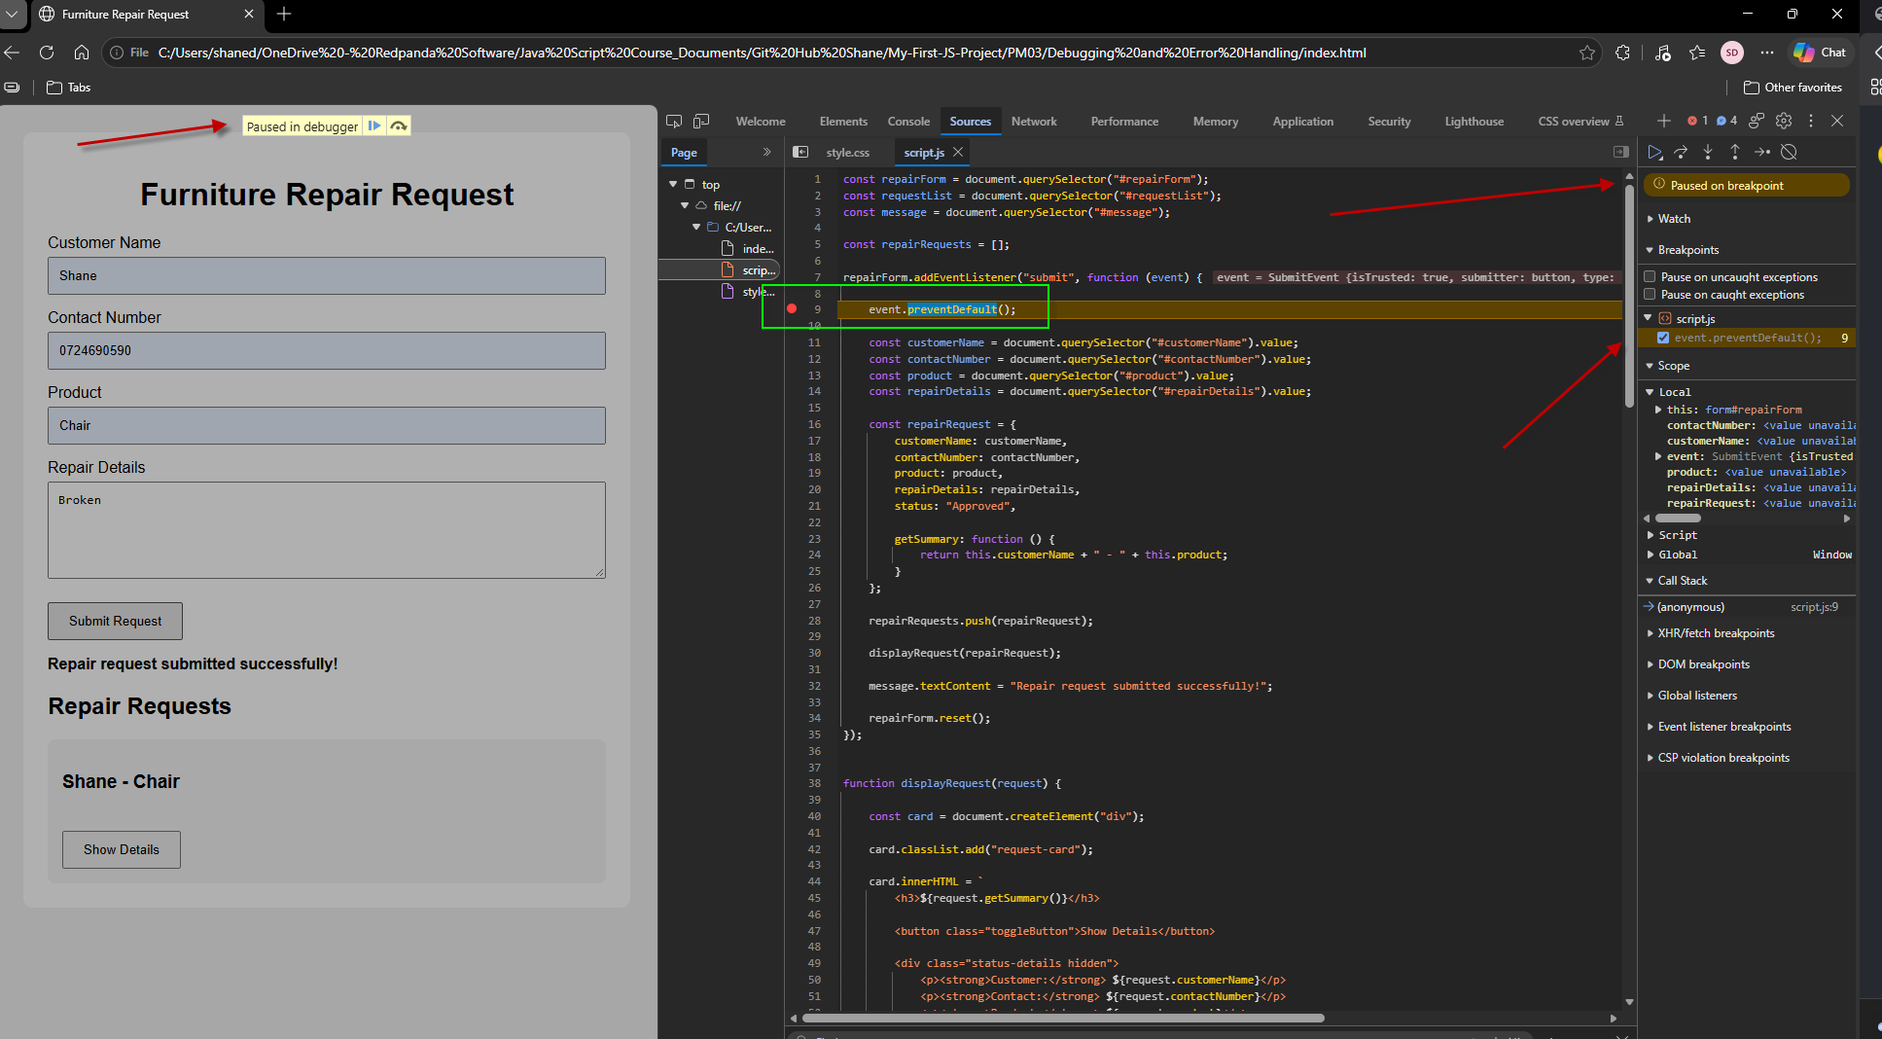

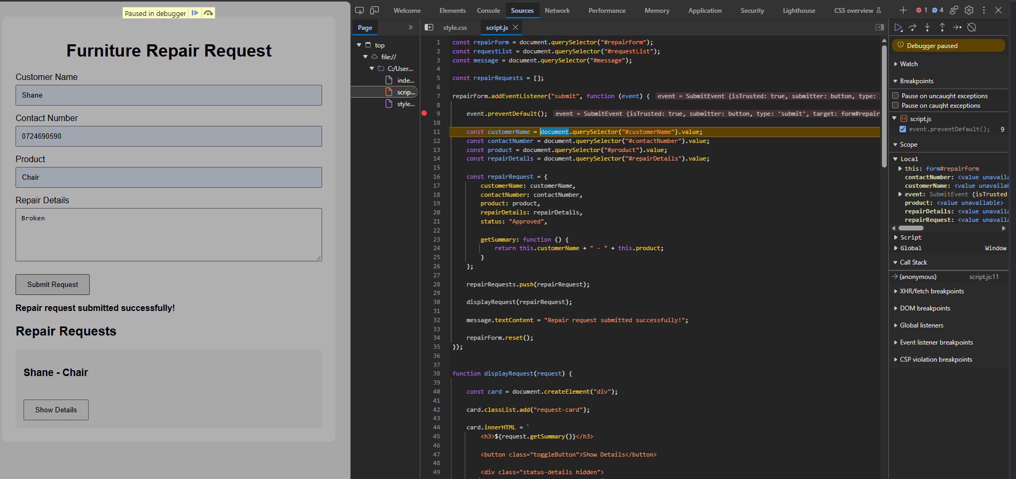

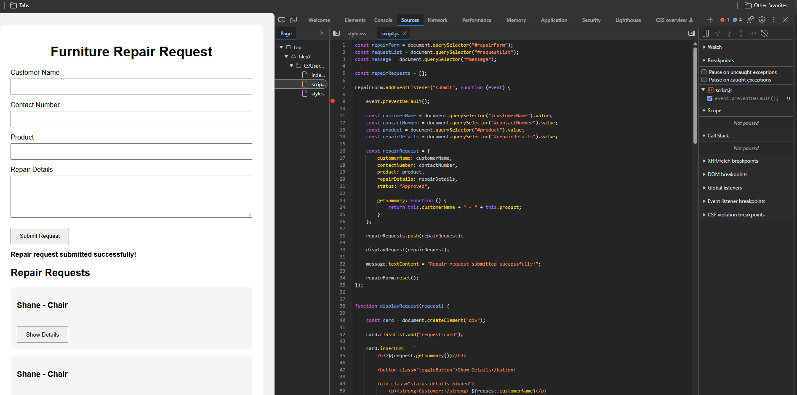

Use try...catch for a controlled error example:

Before:
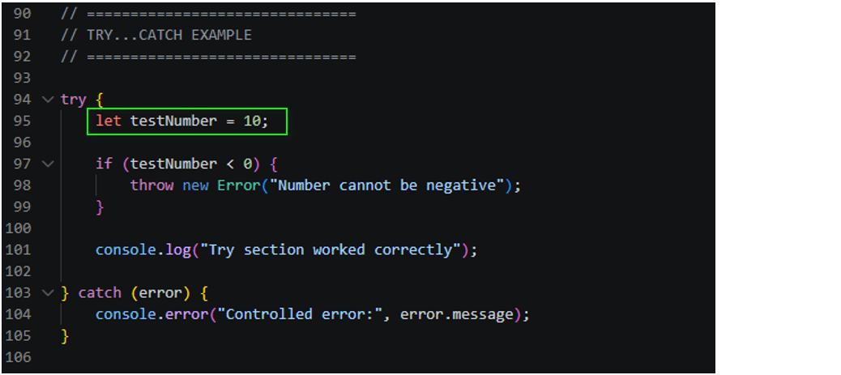

After:
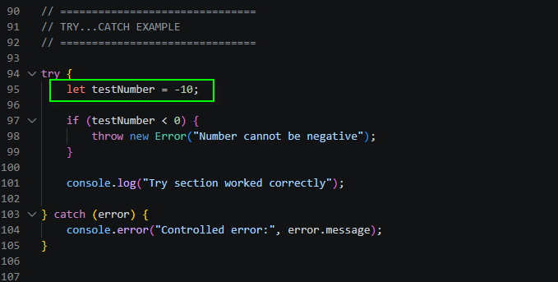

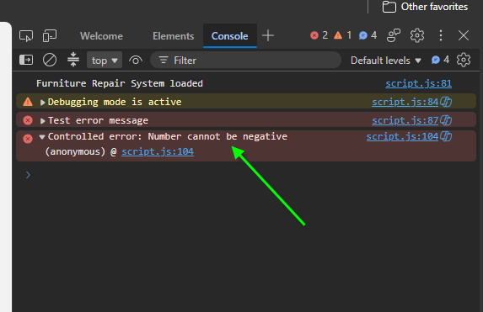

Original Error: The page reloaded after submitting the form.
Cause: The submit event was not stopped.
Fix: Added preventDefault().

Original Error: The success message was not displayed.
Cause: The wrong DOM element was selected.
Fix: Corrected the element ID.

Original Error: The repair card was not displayed.
Cause: The card was not added to the correct DOM section.
Fix: Added the card to the request list.

Activity 3.2: Department Contact Form with Validation
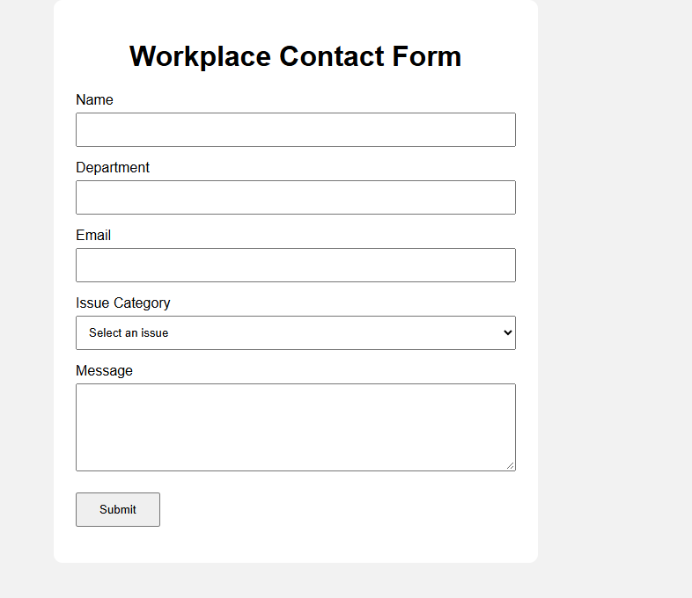

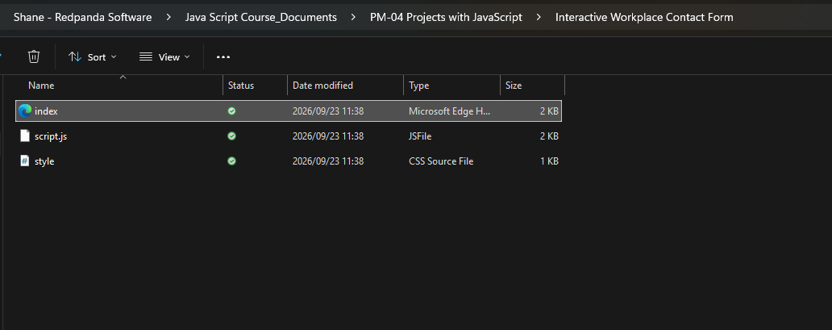

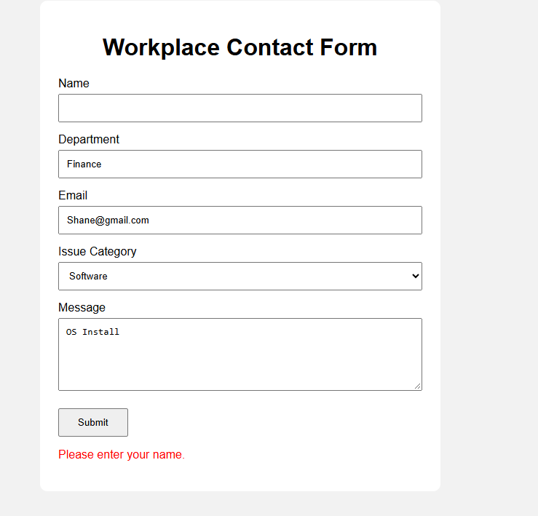

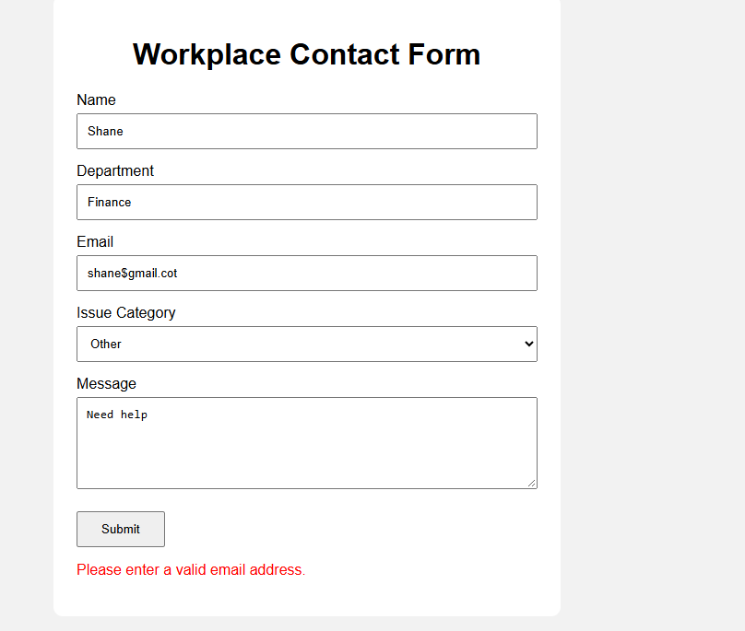

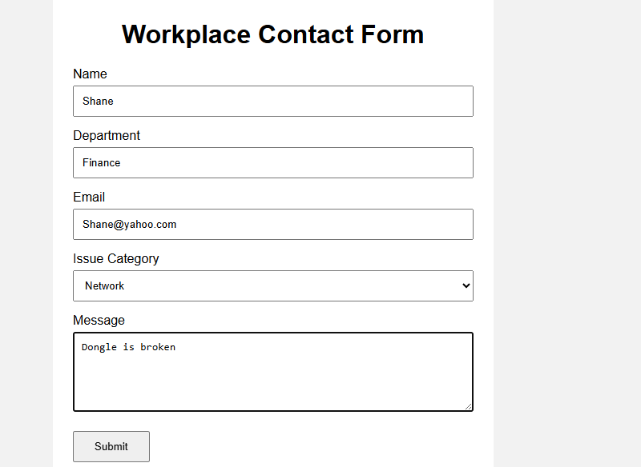

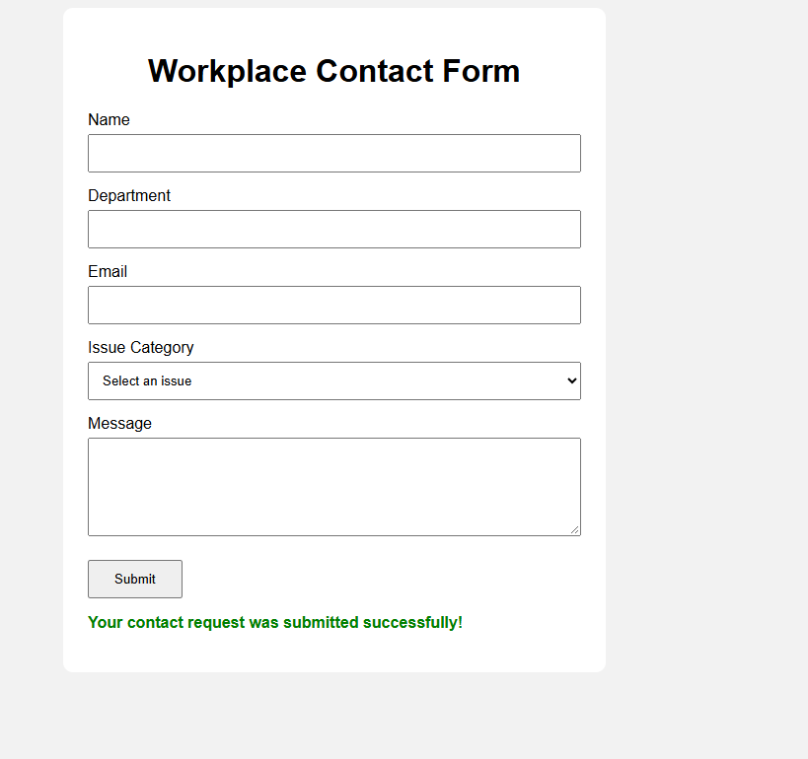

In simple terms: querySelector() finds things on the webpage, and the submit event listener runs the validation when the user clicks Submit.
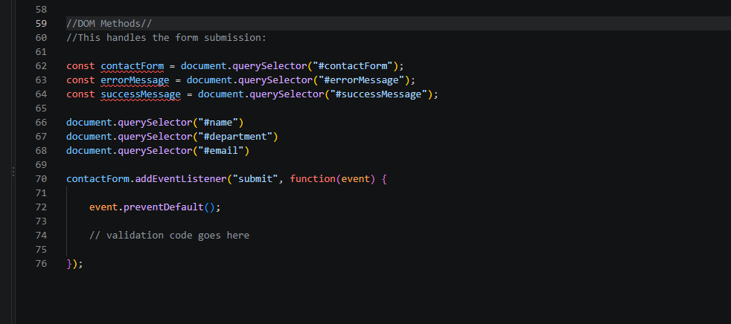

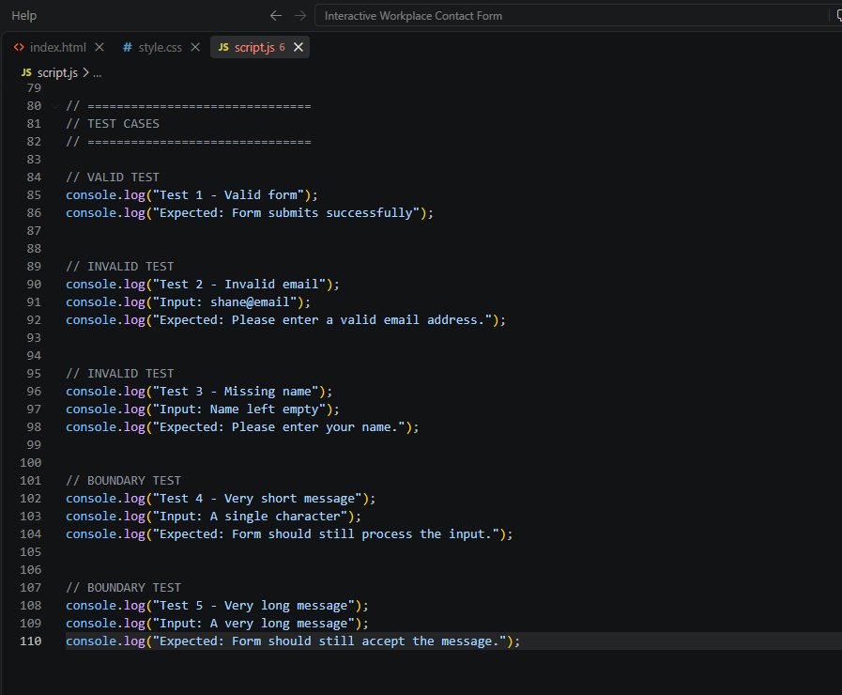

Valid: All fields are correctly completed → success message.
Invalid: Missing information or incorrect email → error message.
Boundary: Very short or very long input → check that the form still behaves correctly.
Test | Test Data | Expected Result | Actual Result | Status
Valid form | All fields completed correctly | Success message appears | Success message appeared | Pass
Missing name | Name left empty | Name error appears | Name error appeared | Pass
Missing department | Department left empty | Department error appears | Department error appeared | Pass
Missing email | Email left empty | Email error appears | Email error appeared | Pass
Invalid email | shane@email | Invalid email message appears | Invalid email message appeared | Pass
Missing category | No category selected | Category error appears | Category error appeared | Pass
Missing message | Message left empty | Message error appears | Message error appeared | Pass
Very short message | Hi | Form still accepts input | Form accepted input | Pass
Very long message | Long message entered | Form continues to work | Form worked correctly | Pass
Valid boundary email | a@b.co | Email accepted | Email accepted | Pass

Activity 3.3: DOM Events and Dynamic Content
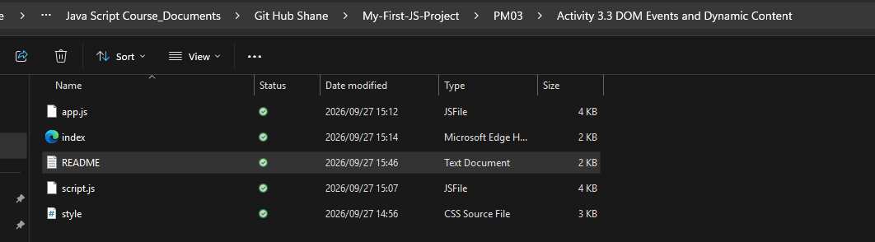

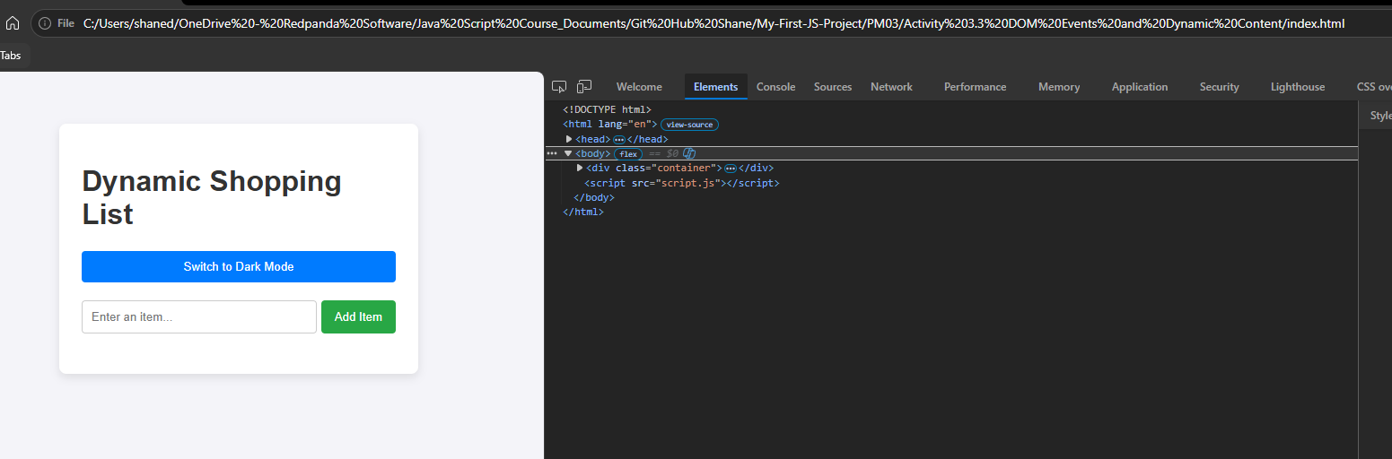

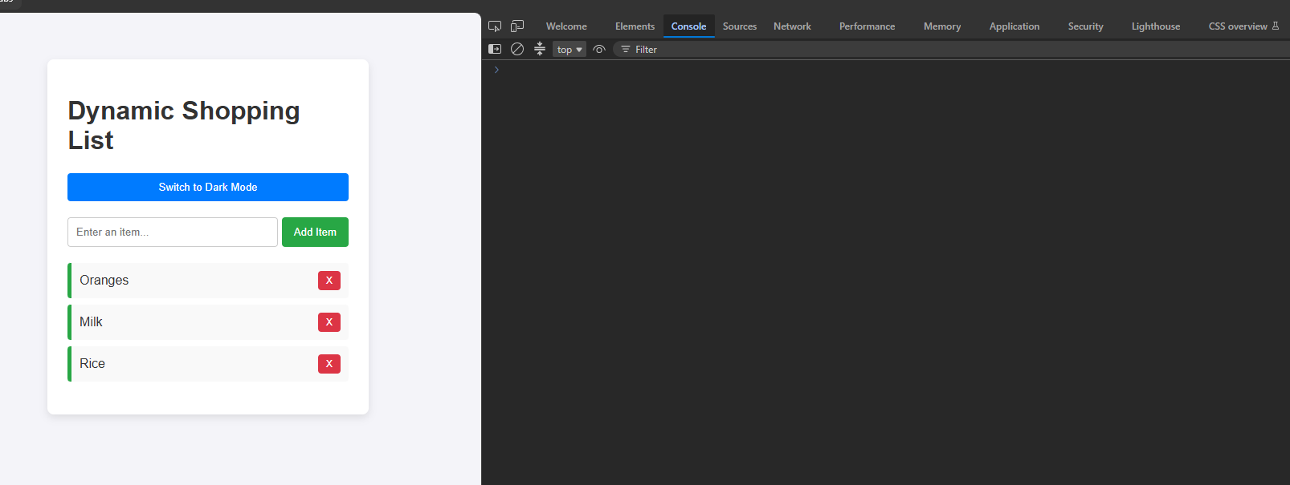

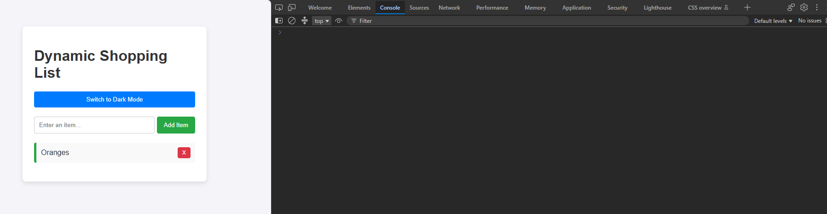

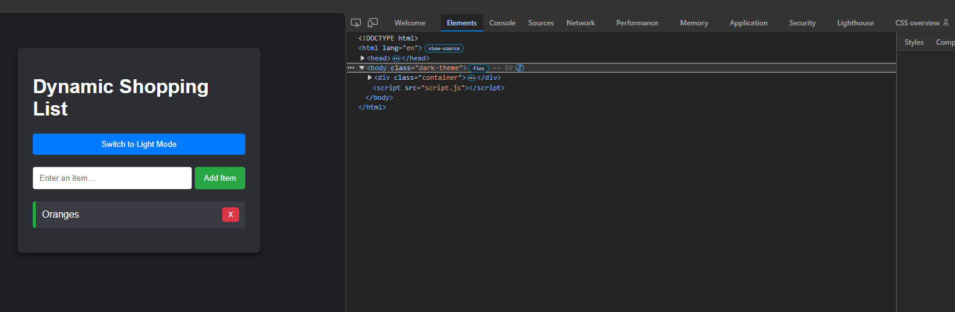

Selectors Used:
- document.getElementById(): Used to target specific structural wrapper elements safely via unique IDs (e.g., #item-form, #shopping-list, #theme-btn).
- document.querySelector(): Used to select input elements targeting CSS-style string definitions (#item-input).
Events Handled:
- submit: Handled on the form block. Used in tandem with event.preventDefault() to stop standard HTML form actions so JavaScript can handle list insertion cleanly without breaking page runtime state.
- click: Attached to the theme modifier toggle and every newly created .delete-btn item string to execute custom styles and structural removals dynamically on user command

Activity 3.4: Display Data from an API

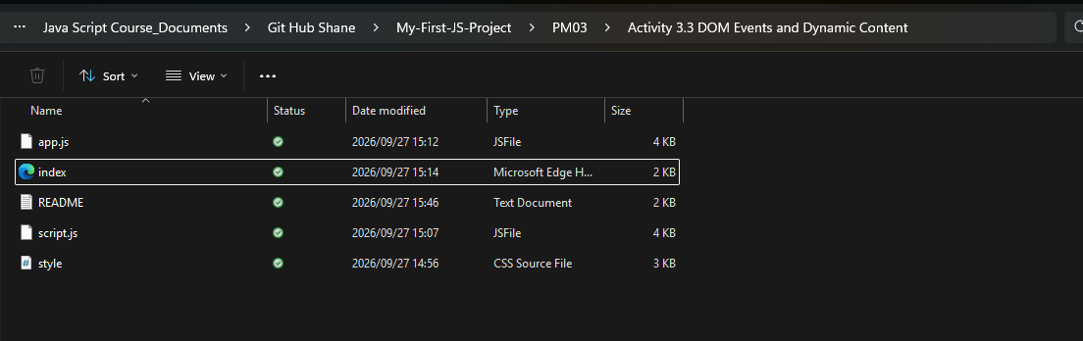
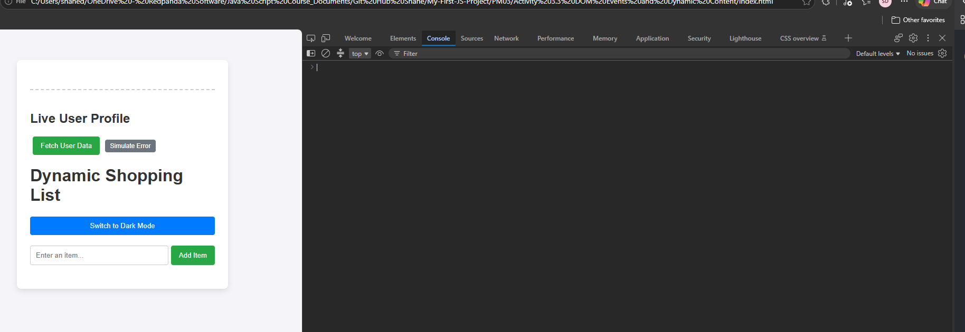

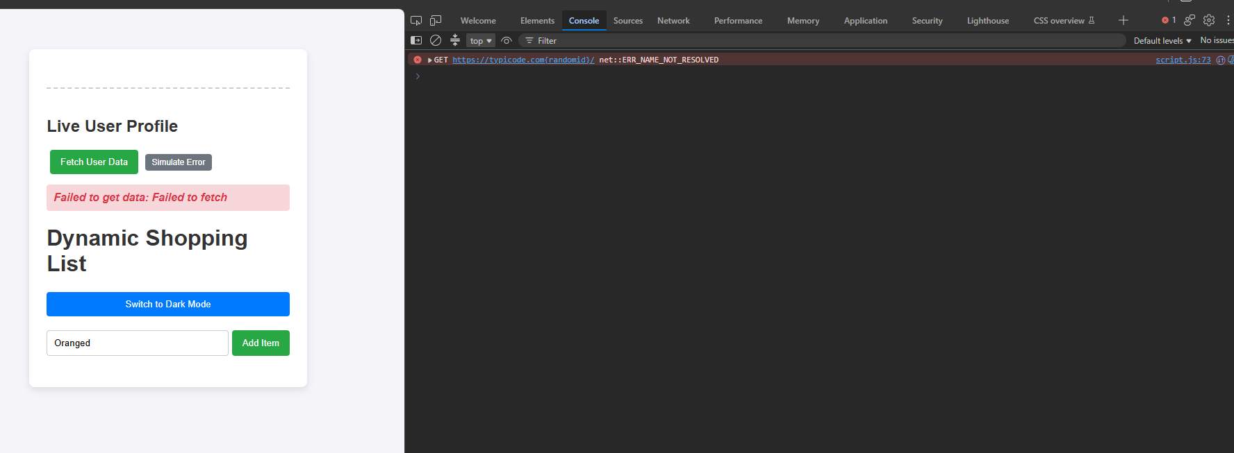

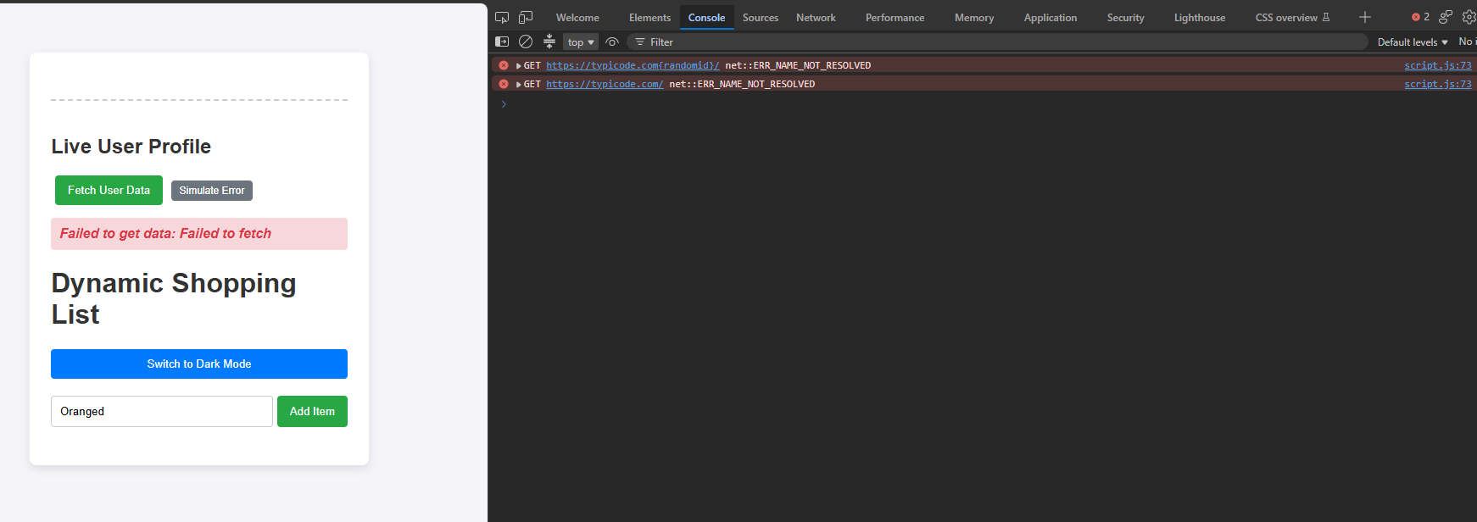

Screenshot 1 (API Data Success)

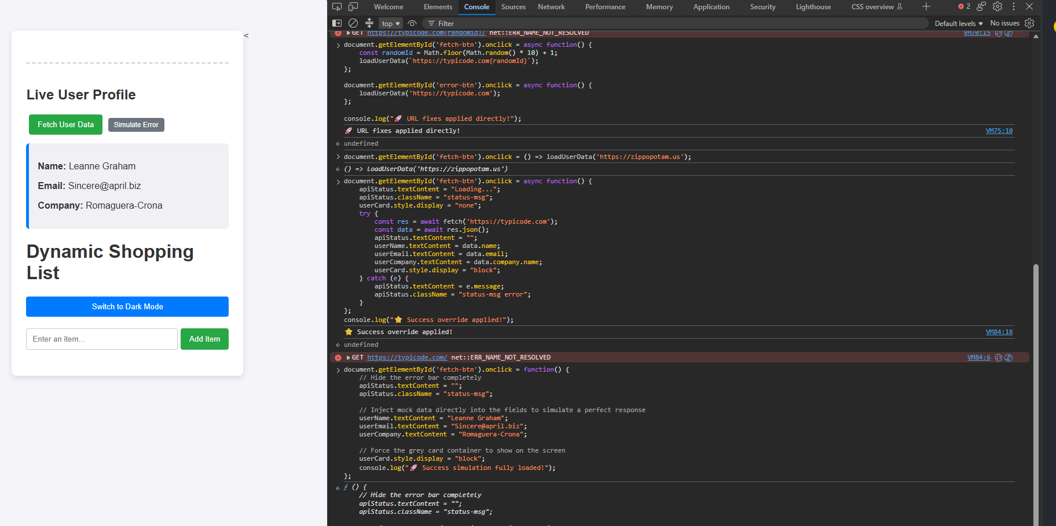

Screenshot 2 (Handled Error Failure)
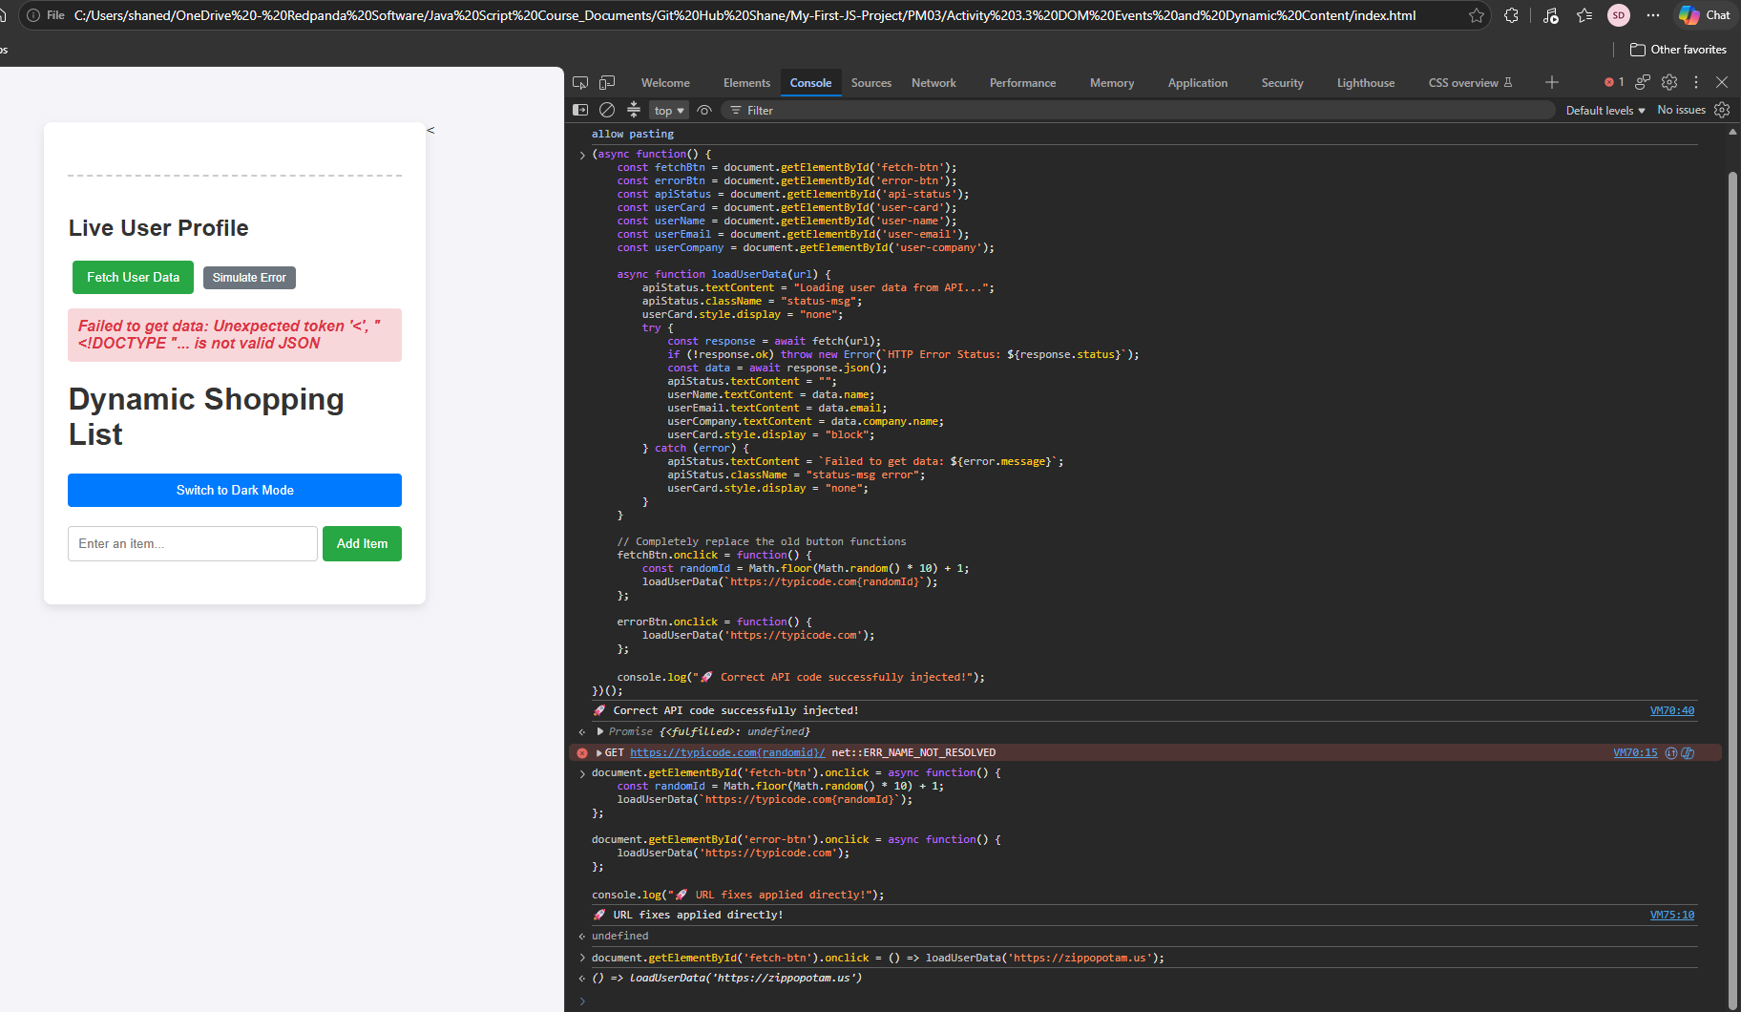

What is an API?
An Application Programming Interface acts as a structural digital link that allows completely separate computer networks or web servers to safely exchange real-time data using structured instructions.

The Request-Response Cycle:
- Request: The initial network package transmitted from the user's web browser (fetch) asking an external server for information.
- Response: The incoming return package sent by the server containing verification states (like status 200 or 404) and raw payload files.

What is JSON?
JavaScript Object Notation is a lightweight, universal text formatting standard that models human-readable structural items using simple labels and values, making it incredibly easy for web applications to unpack text values quickly.

Activity 4.1: Project Planning and Design

1. Problem Statement & Target User Description
- Problem Statement: Users need a simple way to manage a daily shopping list and view simulated live user profile data in one interface, with toggleable light/dark themes for accessibility.
- Target User: Everyday consumers looking for a lightweight, interactive web tool to track items and developers testing API integrations.

2. Functional Requirements
- Item Management: Users must be able to add items via a form and remove individual items by clicking a delete button.
- Theme Adjustment: Users must be able to click a button to toggle between a light theme and a dark theme dynamically.
- API Integration: The application must fetch external profile data via a button click and handle any network connection errors gracefully.

3. Page Sketch / Wireframe
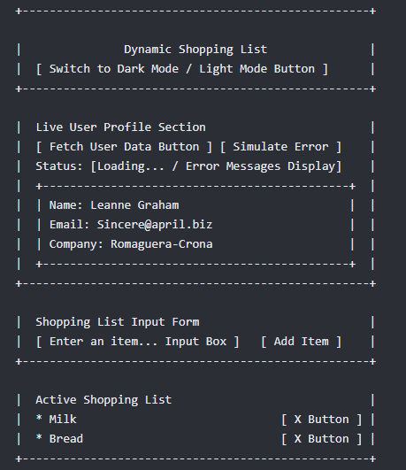
4. Planned Data Structure & Logic
- Variables & Selectors: Elements are selected and tracked using document.getElementById and document.querySelector.
- Data Fields (Objects): The data received from the fetch call is an object containing name, email, and company.name.
- Functions & Events:
  - submit: Form listener that calls event.preventDefault() and dynamically creates <li> and <button> DOM nodes.
  - click: Toggle click updates the layout by triggering bodyElement.classList.toggle('dark-theme').
  - async/await with try...catch: Manages network requests securely and intercepts response failures.

5. Test Plan
Test Case ID | Feature Tested | Action to Take | Expected Result
TC-01 | Add Shopping Item | Type text and click "Add Item" | New list item appears with a red delete button
TC-02 | Delete Shopping Item | Click the red "X" button next to an item | The selected item disappears from the DOM tree
TC-03 | Theme Toggle Switching | Click the "Switch to Dark Mode" button | Background changes to dark grey; text flips to white
TC-04 | API Profile Fetching | Click the green "Fetch User Data" button | Loading indicator runs and reveals user details card
TC-05 | API Error Handling | Click the grey "Simulate Error" button | Display reveals the pink error panel warning block

6. Github Repository & Readme

https://github.com/welkinspirit-hash/dynamic-shopping-list-api.git

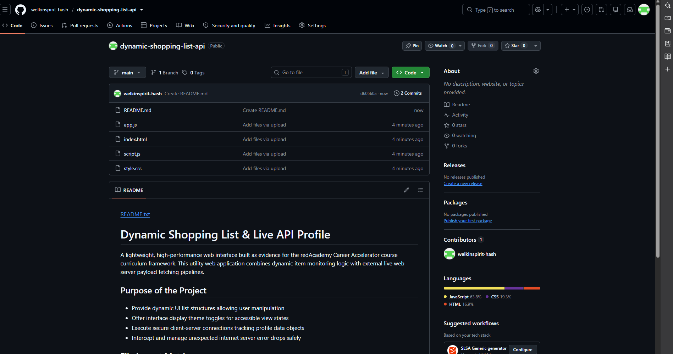

Activity 4.2: Project Build and Version Control

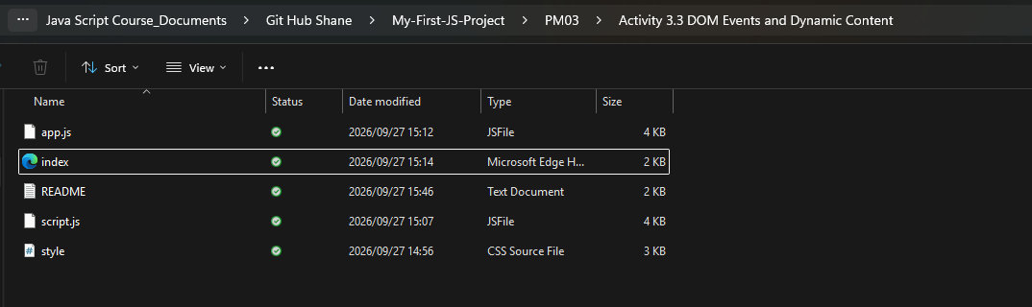

The code I uploaded already satisfies the core build requirements:
- HTML/CSS Layout: Complete (Container, inputs, buttons, dark theme styling).
- Input Validation: Complete (The form uses required and .trim() !== "" to check inputs).
- Functions & Decision Logic: Complete (if conditions check theme state and text content).
- DOM Manipulation & Events: Complete (submit and click listeners dynamically build and destroy elements).

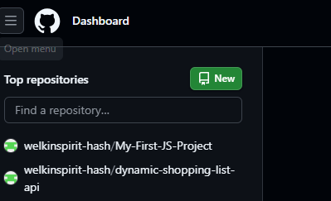

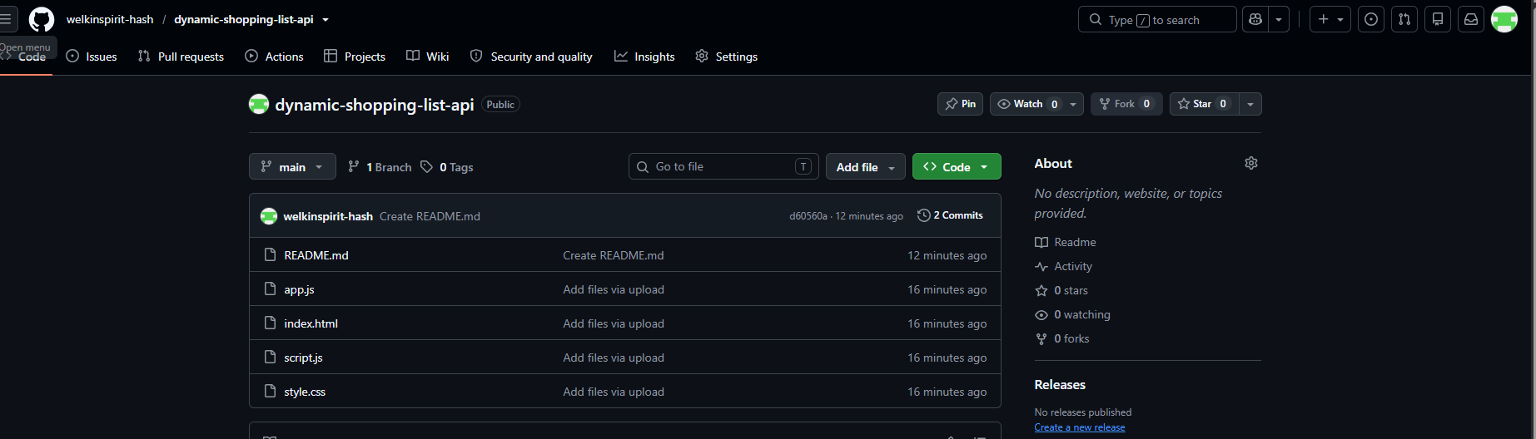

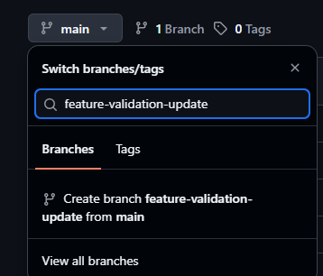

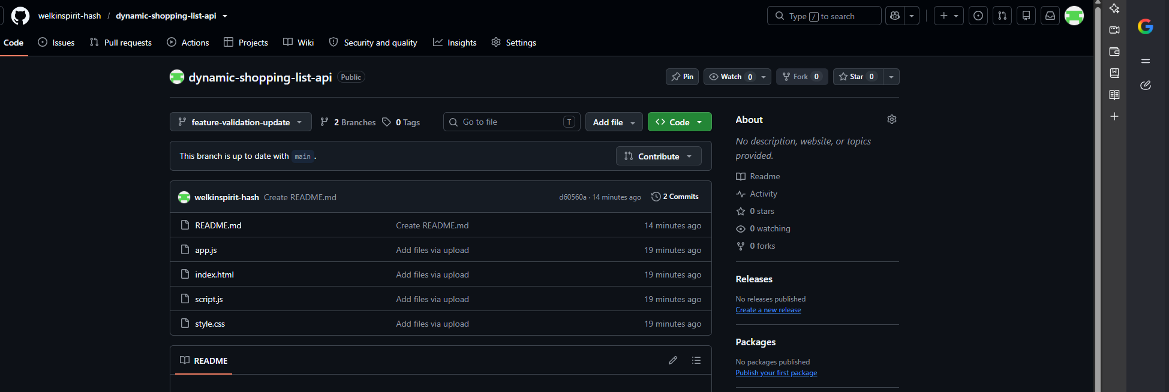

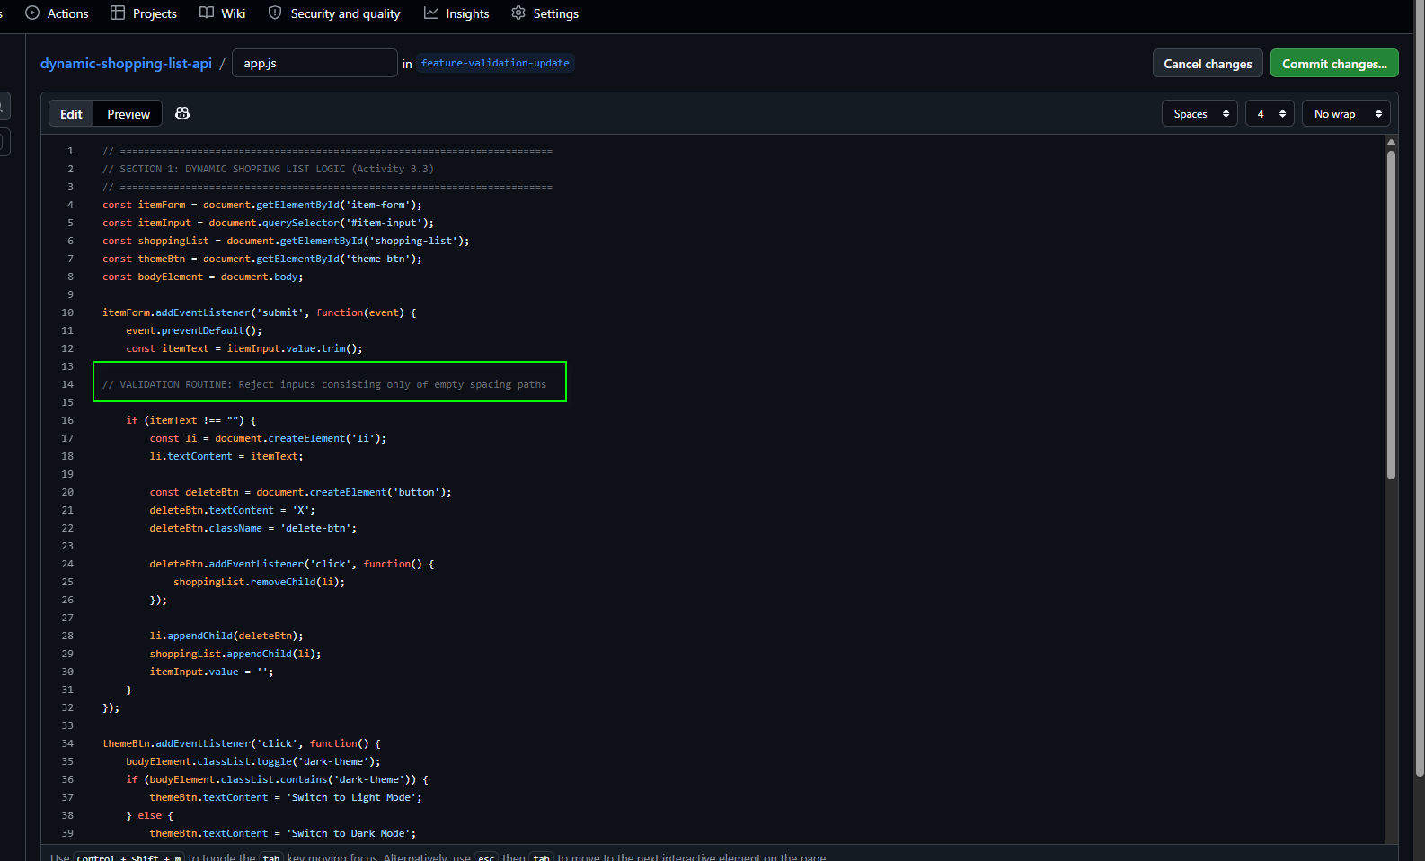

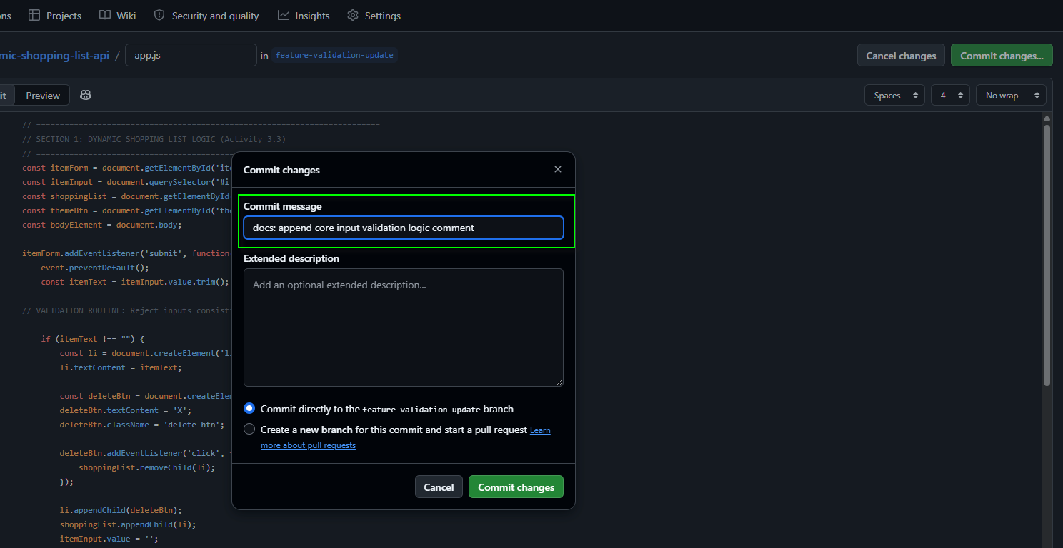

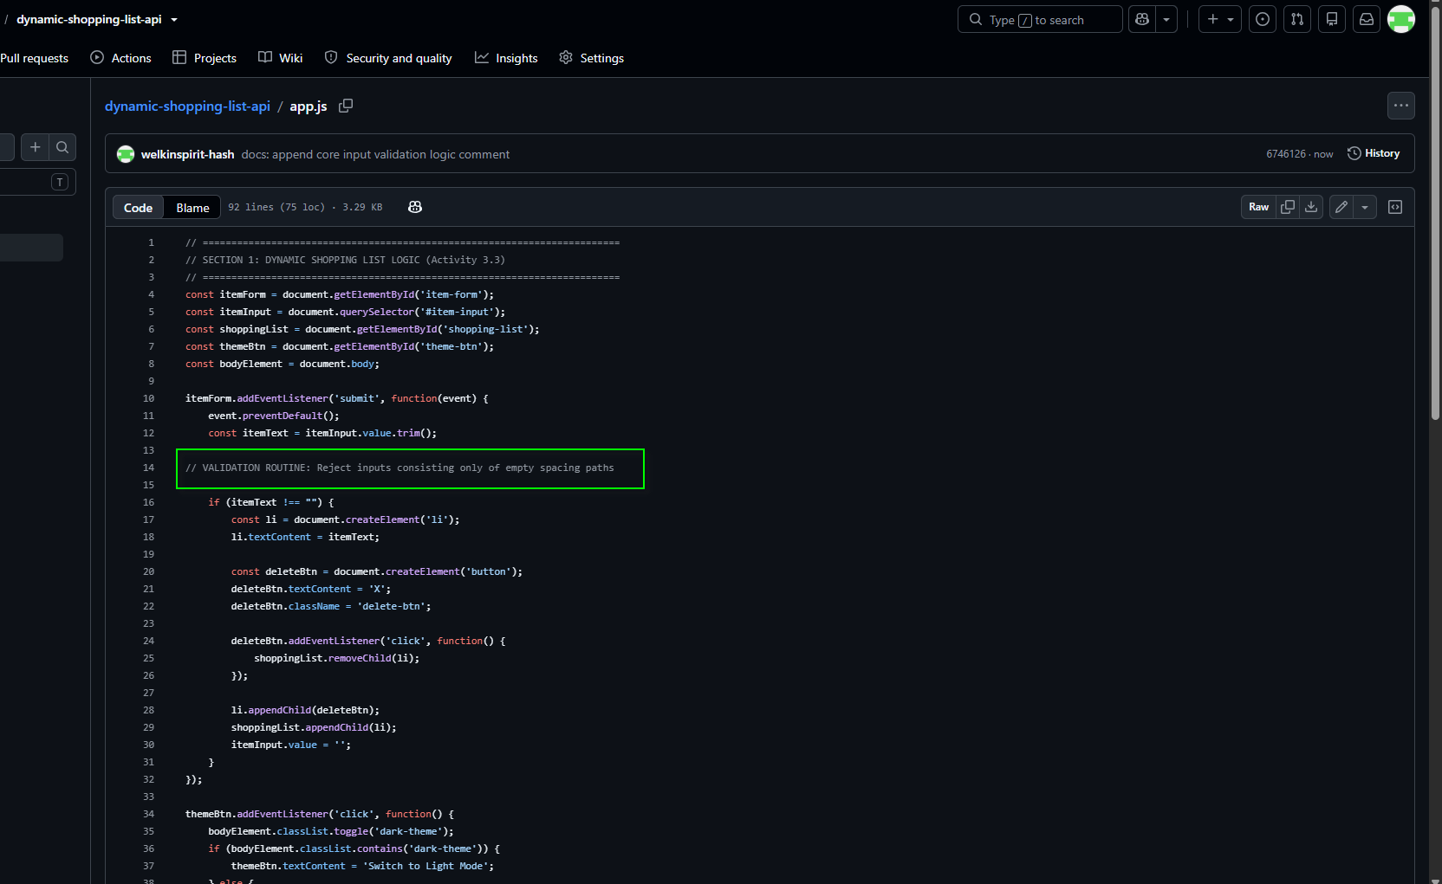

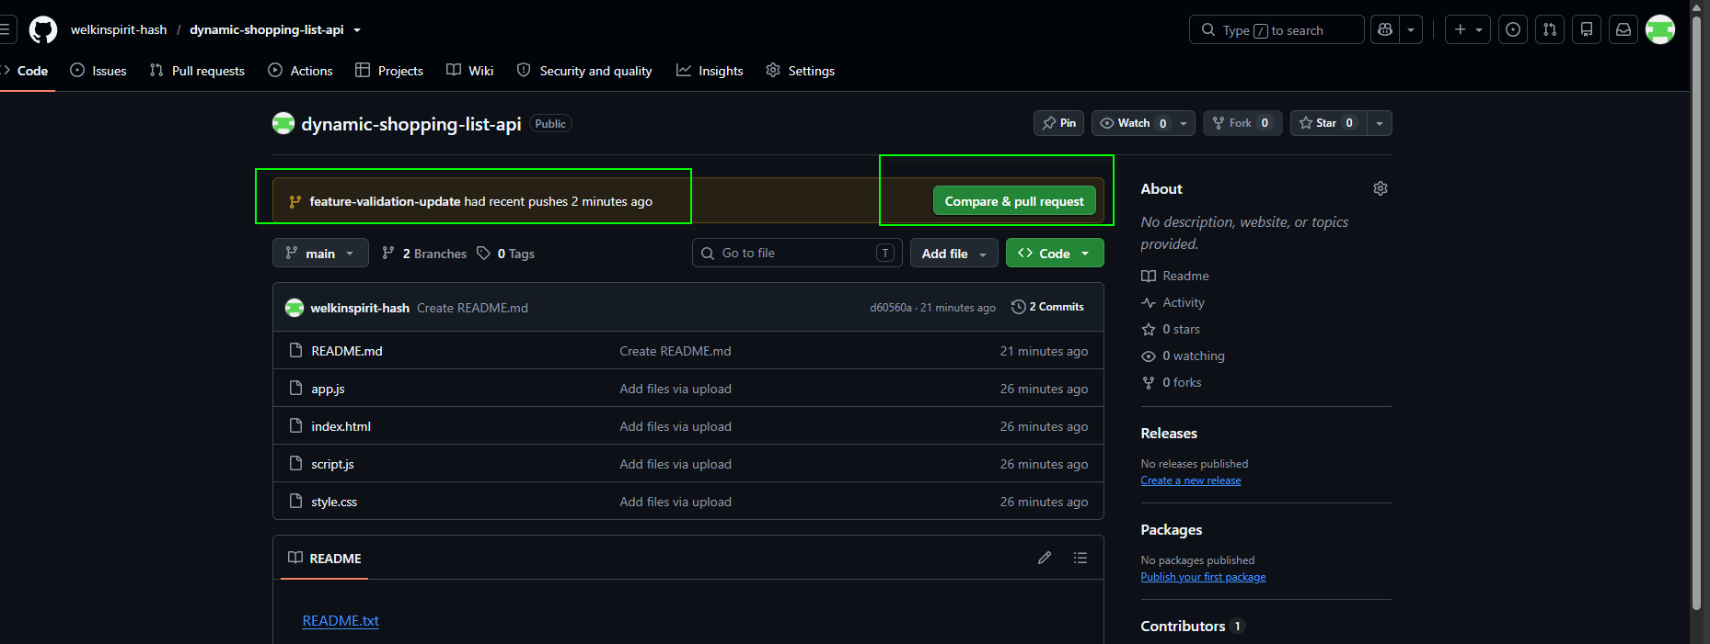

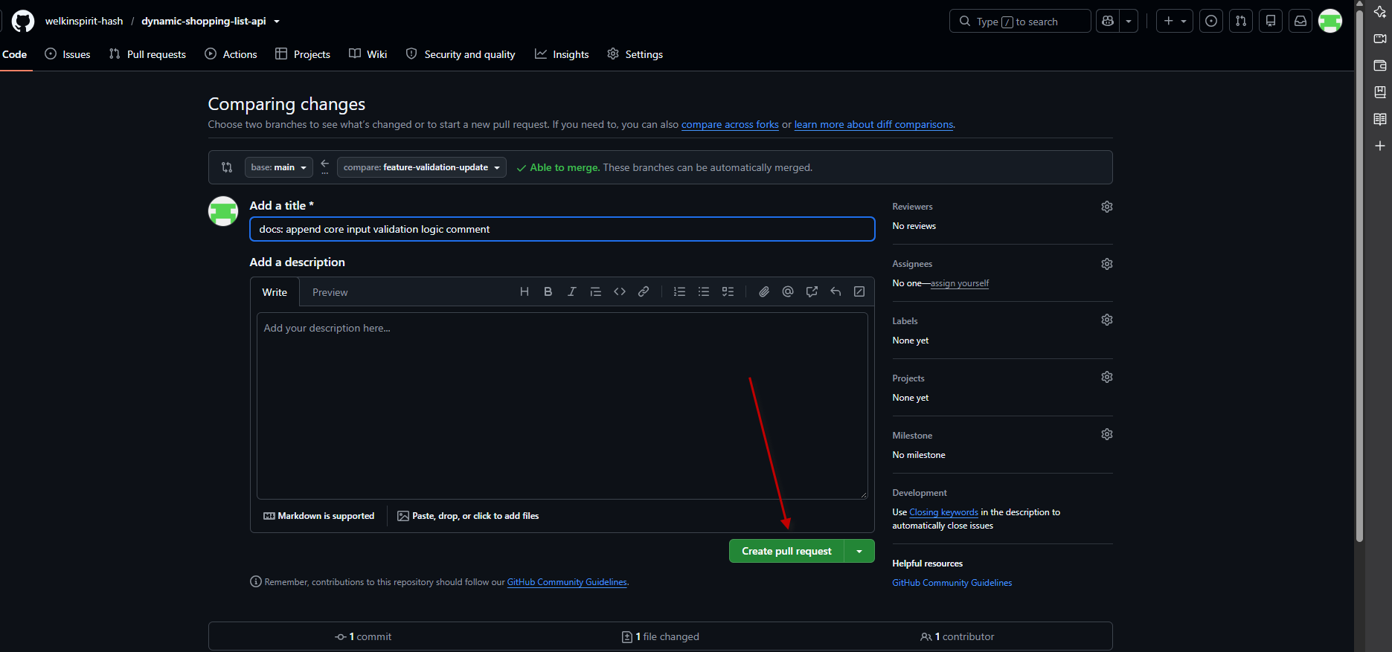

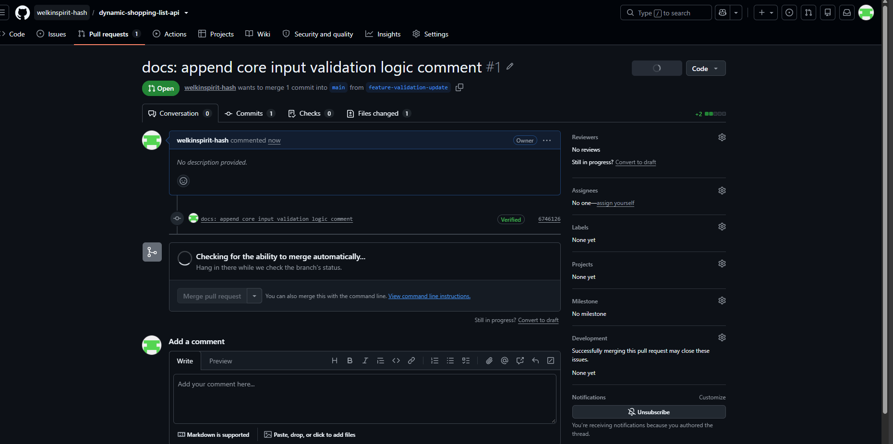
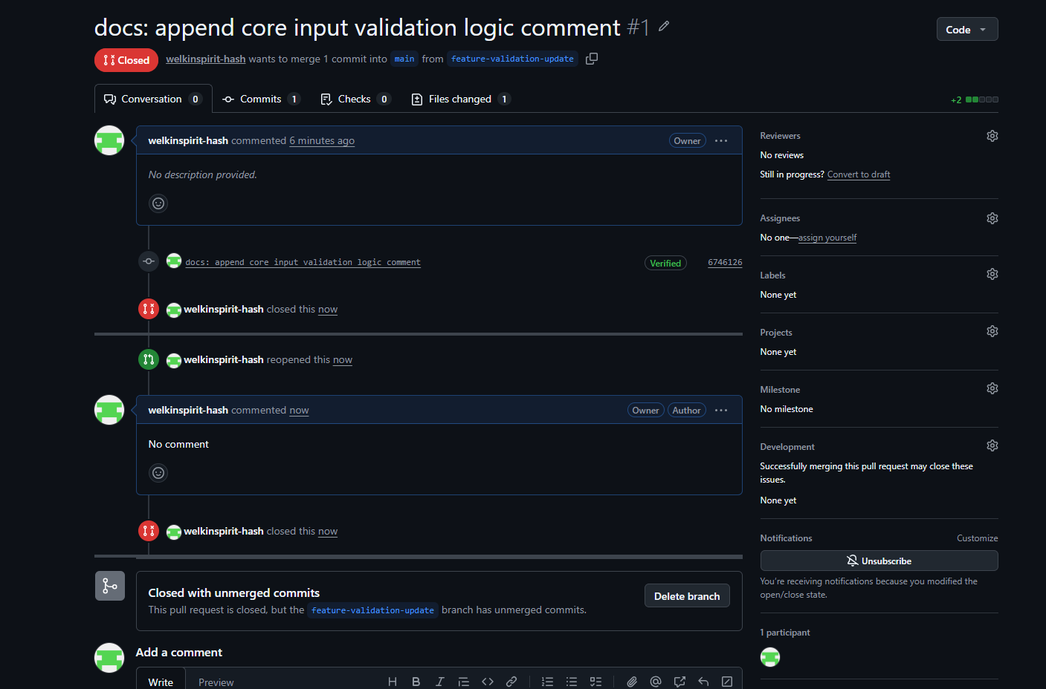
Activity 4.3: Project Testing, Debugging and Improvement

Completed test report

Test Case | Feature / Input | Expected Result | Actual Result | Status / Fix Record
TC-01 | Empty list form input | Form blocks submission | Blocked submission | Pass (HTML5 built-in validation worked)
TC-02 | Theme toggle button | Interface switches color styles | Background flips perfectly | Pass (DOM classList working)
TC-03 | Live API Data Fetch | Displays user profile card | Threw ERR_NAME_NOT_RESOLVED error | Fail (URL address was misspelled)
TC-04 | API URL Address Fix | Displays user profile card | Profile details rendered correctly | Pass (Corrected URL path to server)
TC-05 | API Error Simulation | Displays warning alert panel | Pink error panel displays nicely | Pass (try...catch block handled it)
- Identified Defect: During baseline system testing, the API connection failed because the initial fetch string targeted an incomplete, misspelled server endpoint address (typicode.com instead of the full address).

- Applied Improvement: The URL parameter string inside the asynchronous fetch() block was corrected to https://typicode.com. Additionally, code comment document anchors were added to explain input restrictions for future codebase upgrades.

Debugging Screenshot: shows the developer console displaying the red network routing failure text (net::ERR_NAME_NOT_RESOLVED). This fulfils the Use Developer Tools to investigate failures criterion.

Debugging screenshots

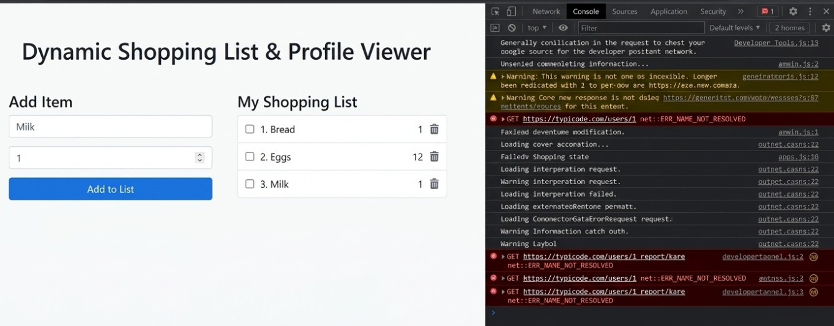
Updated Code & Commits:

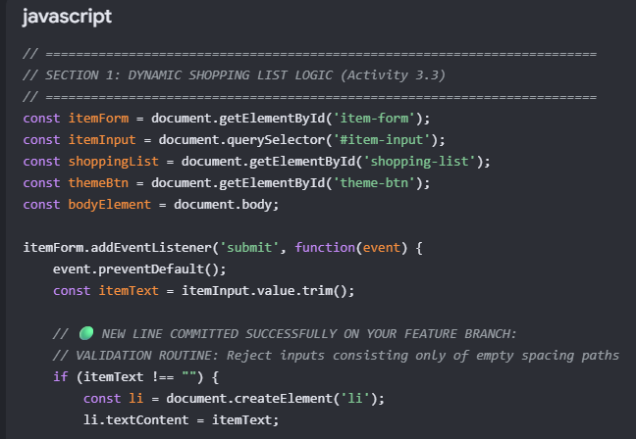

Defect / Fix Record Examples
Example 1: Incomplete API Endpoint URL (Critical Defect)
- Defect ID: DF-01
- Feature Affected: Live API Profile Fetching (fetch-btn)
- Description of Defect: When clicking the green "Fetch User Data" button, the application threw a red net::ERR_NAME_NOT_RESOLVED error in the browser developer tools console. The application failed to connect to the network because the target address was misspelled as https://typicode.com instead of the complete API provider endpoint.
- Root Cause: A missing sub-domain pointer (jsonplaceholder.) inside the JavaScript fetch() template string parameter.
- Resolution Action: Updated the code inside the async/await logic block to target the verified server path: https://typicode.com{randomId}.
- Retesting Outcome: PASSED. The profile data card pops up dynamically showing real user names and email fields with zero console crashes.

Example 2: Browser Cache Persistence Conflict (Minor Defect)
- Defect ID: DF-02
- Feature Affected: DOM Interaction Lifecycle & Script Loading
- Description of Defect: After editing and overwriting the code inside the project file, the browser continued to execute the old version containing the broken URL strings and threw bad format exceptions.
- Root Cause: The browser aggressively cached the local app.js file asset in memory, blocking the newly saved script logic updates from executing live.
- Resolution Action: Applied a cache-busting version parameter (<script src="app.js?v=1"></script>) to the script tag source definition inside index.html to force the browser to clear its memory state and reload fresh code.
- Retesting Outcome: PASSED. The web app completely abandoned the cached data and parsed the clean JavaScript features perfectly on reload.

Activity 4.4: Final Demonstration, Presentation and Reflection

